Government College of Engineering, Karad Programming for Problem Solving Lab

Nanekar Saurabh Rajesh

20141212

I1

**Experiment No. 9**

**Title**: Implement a program to perform following operations on singly linked list/ create, insert – start, end, in-between, search, delete, and display.

**Outcome:** Students can perform linked list operations and its related applications.

**Theory:**

**What is Linked List?**

When we want to work with an unknown number of data values, we use a linked list data structure to organize that data. The linked list is a linear data structure that contains a sequence of elements such that each element links to its next element in the sequence. Each element in a linked list is called "Node".

**What is Single Linked List?**

Simply a list is a sequence of data, and the linked list is a sequence of data linked with each other.  
The formal definition of a single linked list is as follows...

**Single linked list is a sequence of elements in which every element has link to its next element in the sequence**

In any single linked list, the individual element is called as "Node". Every "Node" contains two fields, data field, and the next field. The data field is used to store actual value of the node and next field is used to store the address of next node in the sequence.  
The graphical representation of a node in a single linked list is as follows...



Important Points to be remembered:

In a single linked list, the address of the first node is always stored in a reference node known as "front" (Some times it is also known as "head").

Always next part (reference part) of the last node must be NULL.

**Example:**

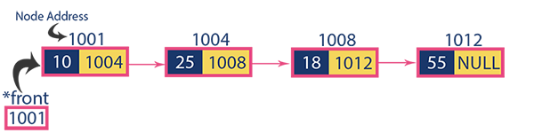

**Operations on Single Linked List**

The following operations are performed on a Single Linked List

* **Insertion**
* **Deletion**
* **Display**

Before we implement actual operations, first we need to set up an empty list. First, perform the following steps before implementing actual operations.

* **Step 1 -**Include all the **header files** which are used in the program.
* **Step 2 -**Declare all the **user defined functions**.
* **Step 3 -**Define a **Node** structure with two members **data** and **next**
* **Step 4 -**Define a Node pointer **'head'** and set it to **NULL**.
* **Step 5 -**Implement the main method by displaying operations menu and make suitable function calls in the main method to perform user selected operation.

**Insertion**

In a single linked list, the insertion operation can be performed in three ways. They are as follows...

1. Inserting At Beginning of the list
2. Inserting At End of the list
3. Inserting At Specific location in the list

**Inserting At Beginning of the list**

We can use the following steps to insert a new node at beginning of the single linked list...

* **Step 1 -**Create a **newNode** with given value.
* **Step 2 -**Check whether list is **Empty** (**head** == **NULL**)
* **Step 3 -**If it is **Empty** then, set **newNode→next** = **NULL** and **head** = **newNode**.
* **Step 4 -**If it is **Not Empty** then, set **newNode→next** = **head** and **head** = **newNode**.

**Inserting At End of the list**

We can use the following steps to insert a new node at end of the single linked list...

* **Step 1 -**Create a **newNode** with given value and **newNode → next** as **NULL**.
* **Step 2 -**Check whether list is **Empty** (**head** == **NULL**).
* **Step 3 -**If it is **Empty** then, set **head** = **newNode**.
* **Step 4 -**If it is **Not Empty** then, define a node pointer **temp** and initialize with **head**.
* **Step 5 -**Keep moving the **temp** to its next node until it reaches to the last node in the list (until **temp → next** is equal to **NULL**).
* **Step 6 -**Set **temp → next** = **newNode**.

**Inserting At Specific location in the list (After a Node)**

We can use the following steps to insert a new node after a node in the single linked list...

* **Step 1 -**Create a **newNode** with given value.
* **Step 2 -**Check whether list is **Empty** (**head** == **NULL**)
* **Step 3 -**If it is **Empty** then, set **newNode → next** = **NULL** and **head** = **newNode**.
* **Step 4 -**If it is **Not Empty** then, define a node pointer **temp** and initialize with **head**.
* **Step 5 -**Keep moving the **temp** to its next node until it reaches to the node after which we want to insert the newNode (until **temp1 → data** is equal to **location**, here location is the node value after which we want to insert the newNode).
* **Step 6 -**Every time check whether **temp** is reached to last node or not. If it is reached to last node then display **'Given node is not found in the list!!! Insertion not possible!!!'** and terminate the function. Otherwise move the **temp** to next node.
* **Step 7 -**Finally, Set '**newNode → next** = **temp → next**' and '**temp → next** = **newNode**'

**Deletion**

In a single linked list, the deletion operation can be performed in three ways. They are as follows...

1. Deleting from Beginning of the list
2. Deleting from End of the list
3. Deleting a Specific Node

**Deleting from Beginning of the list**

We can use the following steps to delete a node from beginning of the single linked list...

* **Step 1 -**Check whether list is **Empty** (**head** == **NULL**)
* **Step 2 -**If it is **Empty** then, display **'List is Empty!!! Deletion is not possible'** and terminate the function.
* **Step 3 -**If it is **Not Empty** then, define a Node pointer **'temp'** and initialize with **head**.
* **Step 4 -**Check whether list is having only one node (**temp → next** == **NULL**)
* **Step 5 -**If it is **TRUE** then set **head** = **NULL** and delete **temp** (Setting **Empty** list conditions)
* **Step 6 -**If it is **FALSE** then set **head** = **temp → next**, and delete **temp**.

**Deleting from End of the list**

We can use the following steps to delete a node from end of the single linked list...

* **Step 1 -**Check whether list is **Empty** (**head** == **NULL**)
* **Step 2 -**If it is **Empty** then, display **'List is Empty!!! Deletion is not possible'** and terminate the function.
* **Step 3 -**If it is **Not Empty** then, define two Node pointers **'temp1'** and '**temp2'** and initialize '**temp1**' with **head**.
* **Step 4 -**Check whether list has only one Node (**temp1 → next** == **NULL**)
* **Step 5 -**If it is **TRUE**. Then, set **head** = **NULL** and delete **temp1**. And terminate the function. (Setting **Empty** list condition)
* **Step 6 -**If it is **FALSE**. Then, set '**temp2 = temp1**' and move **temp1** to its next node. Repeat the same until it reaches to the last node in the list. (until **temp1 → next** == **NULL**)
* **Step 7 -**Finally, Set **temp2 → next**= **NULL** and delete **temp1**.

**Deleting a Specific Node from the list**

We can use the following steps to delete a specific node from the single linked list...

* **Step 1 -**Check whether list is **Empty** (**head** == **NULL**)
* **Step 2 -**If it is **Empty** then, display **'List is Empty!!! Deletion is not possible'** and terminate the function.
* **Step 3 -**If it is **Not Empty** then, defines two Node pointers **'temp1'** and '**temp2**' and initialize '**temp1**' with **head**.
* **Step 4 -**Keep moving the **temp1** until it reaches to the exact node to be deleted or to the last node. And every time set '**temp2 = temp1**' before moving the '**temp1**' to its next node.
* **Step 5 -**If it is reached to the last node then display **'Given node not found in the list! Deletion not possible!!!'**. And terminate the function.
* **Step 6 -**If it is reached to the exact node which we want to delete, then check whether list is having only one node or not
* **Step 7 -**If list has only one node and that is the node to be deleted, then set **head** = **NULL** and delete **temp1** (**free(temp1)**).
* **Step 8 -**If list contains multiple nodes, then check whether **temp1** is the first node in the list (**temp1 == head**).
* **Step 9 -**If **temp1** is the first node then move the **head** to the next node (**head = head → next**) and delete **temp1**.
* **Step 10 -**If **temp1** is not first node then check whether it is last node in the list (**temp1 → next == NULL**).
* **Step 11 -**If **temp1** is last node then set **temp2 → next** = **NULL** and delete **temp1** (**free(temp1)**).
* **Step 12 -**If **temp1** is not first node and not last node then set **temp2 → next** = **temp1 → next** and delete **temp1** (**free(temp1)**).

**Displaying a Single Linked List**

We can use the following steps to display the elements of a single linked list...

* **Step 1 -**Check whether list is **Empty** (**head** == **NULL**)
* **Step 2 -**If it is **Empty** then, display **'List is Empty!!!'** and terminate the function.
* **Step 3 -**If it is **Not Empty** then, define a Node pointer **'temp'** and initialize with **head**.
* **Step 4 -**Keep displaying **temp → data** with an arrow (**--->**) until **temp** reaches to the last node
* **Step 5 -**Finally display **temp → data** with arrow pointing to **NULL** (**temp → data ---> NULL**).

**Analysis:**



**List of similar programs: Solve any one.**

1. Write a C program to Merge a linked list into another linked list at alternate positions.
2. Write a C program to Create new linked list from two given linked list with greater element at each node.
3. Write a C program to reverse items in the linked list.

Refer <https://www.geeksforgeeks.org/top-20-linked-list-interview-question/> for more practice.

**Title Program:**Implement a program to perform following operations on singly linked list/ create, insert – start, end, in-between, search, delete, and display.

**Source code of Implemented Programs:**

//Nankar Saurabh Rajesh

#include<stdio.h>

#include<stdlib.h>

struct node

{

    int data;

    struct node *next;

};

struct node *head;

void beginsert ();

void lastinsert ();

void randominsert();

void begin_delete();

void last_delete();

void random_delete();

void display();

void search();

void main ()

{

    int choice =0;

    while(choice != 9)

    {

        printf("\n\n*********Main Menu*********\n");

        printf("\nChoose one option from the following list ...\n");

        printf("\n===============================================\n");

        printf("\n1.Insert in begining\n2.Insert at last\n3.Insert at any random location\n4.Delete from Beginning\n 5.Delete from last\n6.Delete node after specified location\n7.Search for an element\n8.Show\n9.Exit\n");

        printf("\nEnter your choice?\n");

        scanf("\n%d",&choice);

        switch(choice)

        {

            case 1:

            beginsert();

            break;

            case 2:

            lastinsert();

            break;

            case 3:

            randominsert();

            break;

            case 4:

            begin_delete();

            break;

            case 5:

            last_delete();

            break;

            case 6:

            random_delete();

            break;

            case 7:

            search();

            break;

            case 8:

            display();

            break;

            case 9:

            exit(0);

            break;

            default:

            printf("Please enter valid choice..");

        }

    }

}

void beginsert()

{

    struct node *ptr;

    int item;

    ptr = (struct node *) malloc(sizeof(struct node *));

    if(ptr == NULL)

    {

        printf("\nOVERFLOW");

    }

    else

    {

        printf("\nEnter value\n");

        scanf("%d",&item);

        ptr->data = item;

        ptr->next = head;

        head = ptr;

        printf("\nNode inserted");

    }

}

void lastinsert()

{

    struct node *ptr,*temp;

    int item;

    ptr = (struct node*)malloc(sizeof(struct node));

    if(ptr == NULL)

    {

        printf("\nOVERFLOW");

    }

    else

    {

        printf("\nEnter value?\n");

        scanf("%d",&item);

        ptr->data = item;

        if(head == NULL)

        {

            ptr -> next = NULL;

            head = ptr;

            printf("\nNode inserted");

        }

        else

        {

            temp = head;

            while (temp -> next != NULL)

            {

                temp = temp -> next;

            }

            temp->next = ptr;

            ptr->next = NULL;

            printf("\nNode inserted");

        }

    }

}

void randominsert()

{

    int i,loc,item;

    struct node *ptr, *temp;

    ptr = (struct node *) malloc (sizeof(struct node));

    if(ptr == NULL)

    {

        printf("\nOVERFLOW");

    }

    else

    {

        printf("\nEnter element value");

        scanf("%d",&item);

        ptr->data = item;

        printf("\nEnter the location after which you want to insert ");

        scanf("\n%d",&loc);

        temp=head;

        for(i=0;i<loc;i++)

        {

            temp = temp->next;

            if(temp == NULL)

            {

                printf("\ncan't insert\n");

                return;

            }

        }

        ptr ->next = temp ->next;

        temp ->next = ptr;

        printf("\nNode inserted");

    }

}

void begin_delete()

{

    struct node *ptr;

    if(head == NULL)

    {

        printf("\nList is empty\n");

    }

    else

    {

        ptr = head;

        head = ptr->next;

        free(ptr);

        printf("\nNode deleted from the begining ...\n");

    }

}

void last_delete()

{

    struct node *ptr,*ptr1;

    if(head == NULL)

    {

        printf("\nlist is empty");

    }

    else if(head -> next == NULL)

    {

        head = NULL;

        free(head);

        printf("\nOnly node of the list deleted ...\n");

    }

    else

    {

        ptr = head;

        while(ptr->next != NULL)

        {

            ptr1 = ptr;

            ptr = ptr ->next;

        }

        ptr1->next = NULL;

        free(ptr);

        printf("\nDeleted Node from the last ...\n");

    }

}

void random_delete()

{

    struct node *ptr,*ptr1;

    int loc,i;

    printf("\n Enter the location of the node after which you want to perform deletion \n");

    scanf("%d",&loc);

    ptr=head;

    for(i=0;i<loc;i++)

    {

        ptr1 = ptr;

        ptr = ptr->next;

        if(ptr == NULL)

        {

            printf("\nCan't delete");

            return;

        }

    }

    ptr1 ->next = ptr ->next;

    free(ptr);

    printf("\nDeleted node %d ",loc+1);

}

void search()

{

    struct node *ptr;

    int item,i=0,flag;

    ptr = head;

    if(ptr == NULL)

    {

        printf("\nEmpty List\n");

    }

    else

    {

        printf("\nEnter item which you want to search?\n");

        scanf("%d",&item);

        while (ptr!=NULL)

        {

            if(ptr->data == item)

            {

                printf("item found at location %d ",i+1);

                flag=0;

            }

            else

            {

                flag=1;

            }

            i++;

            ptr = ptr -> next;

        }

        if(flag==1)

        {

            printf("Item not found\n");

        }

    }

}

void display()

{

    struct node *ptr;

    ptr = head;

    if(ptr == NULL)

    {

        printf("Nothing to print");

    }

    else

    {

        printf("\nprinting values . . . . .\n");

        while (ptr!=NULL)

        {

            printf("\n%d",ptr->data);

            ptr = ptr -> next;

        }

    }

}

**Screenshots of Output:**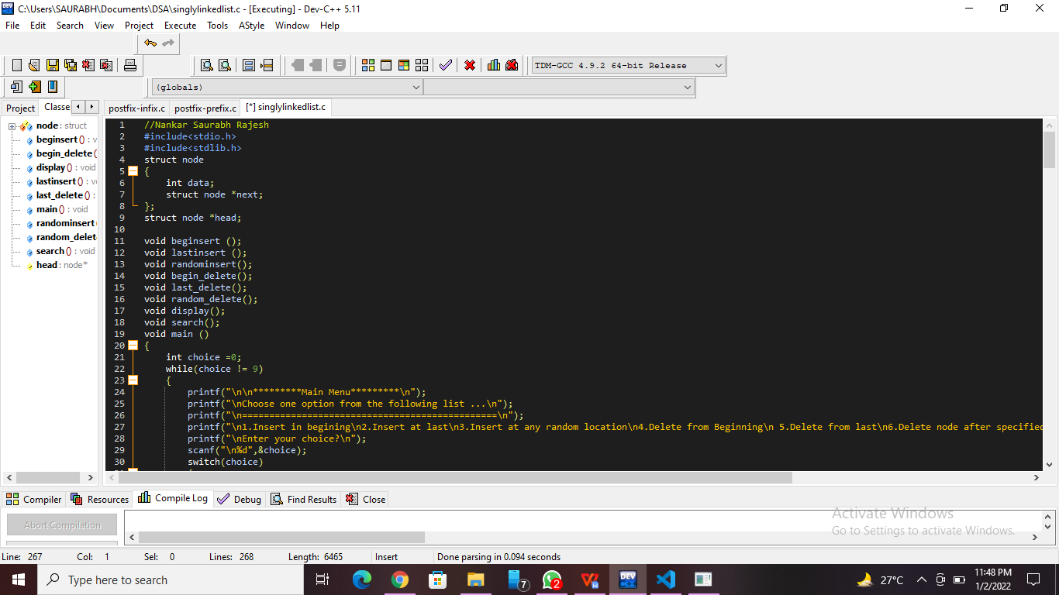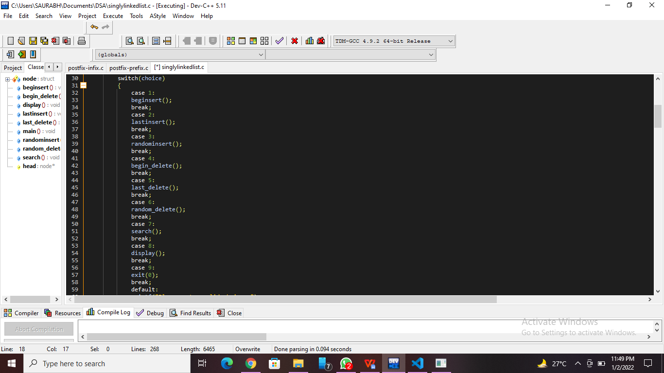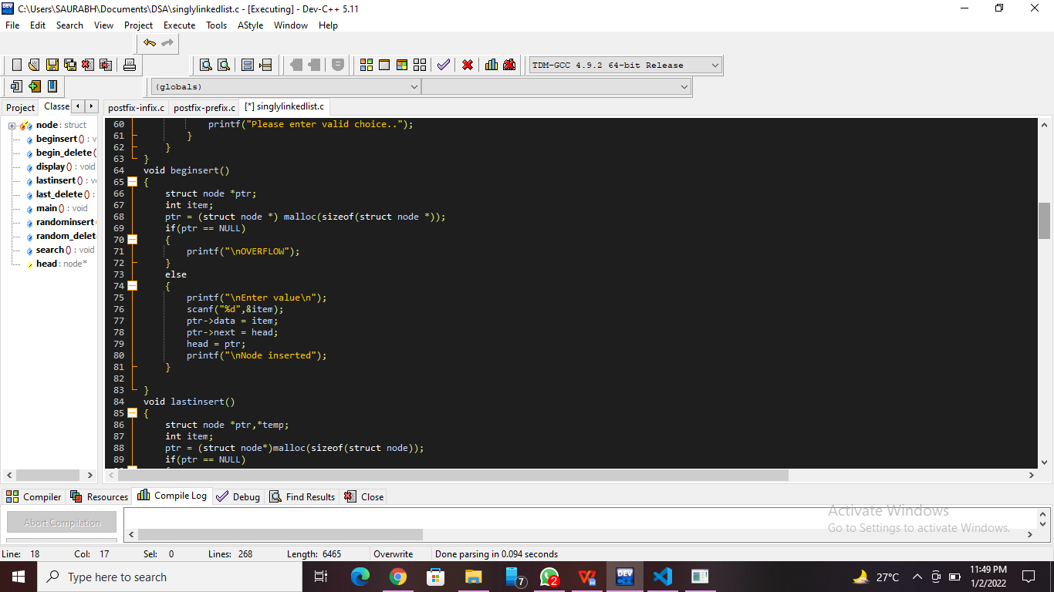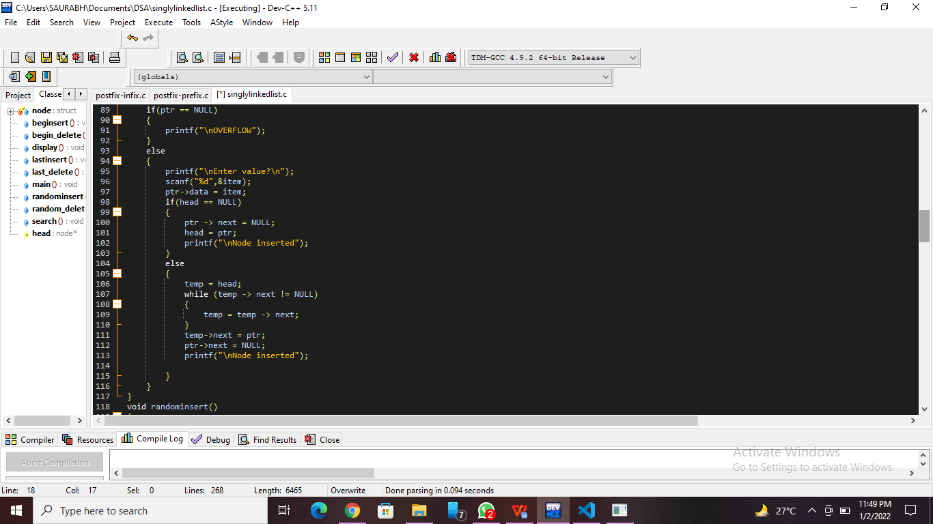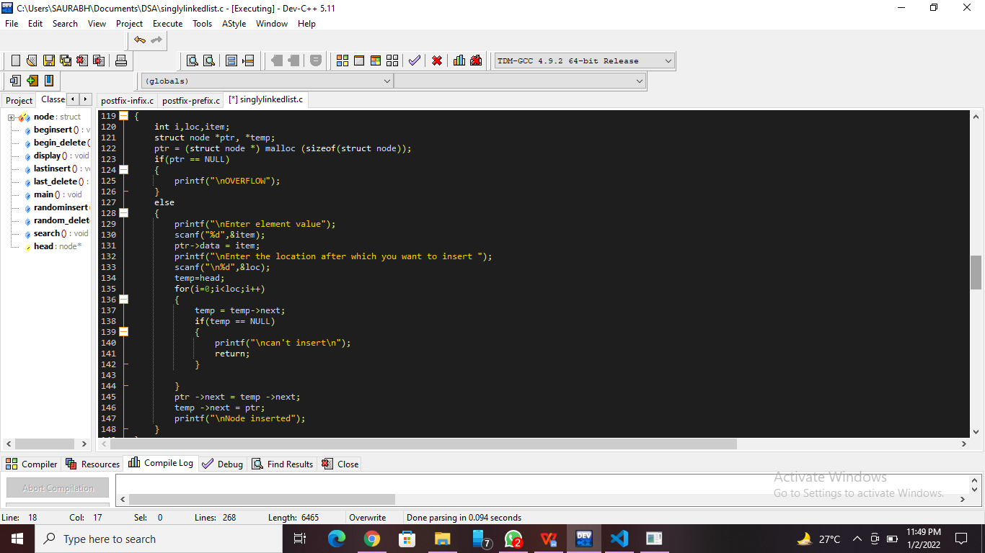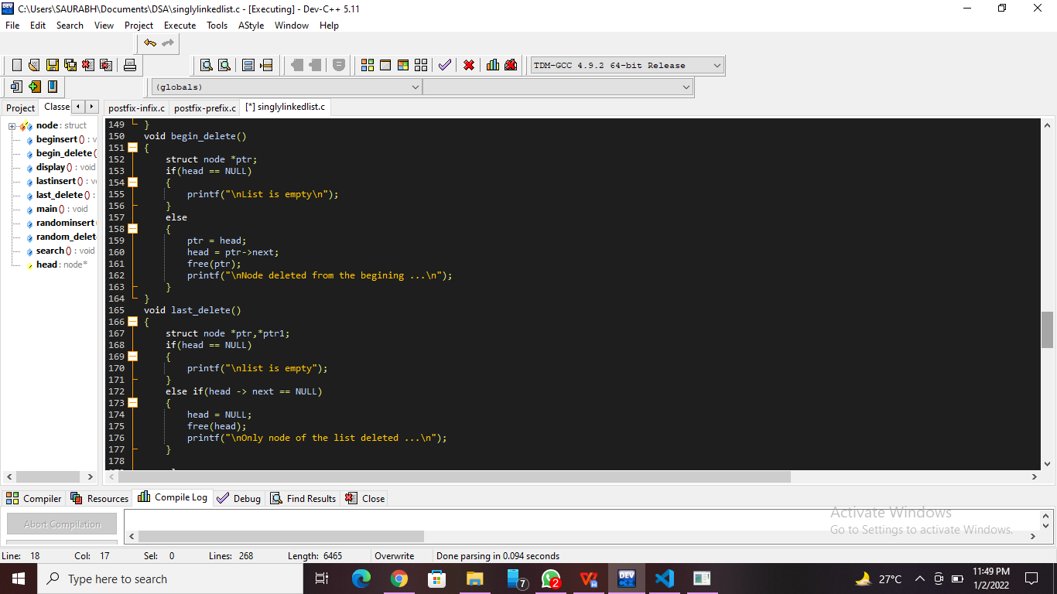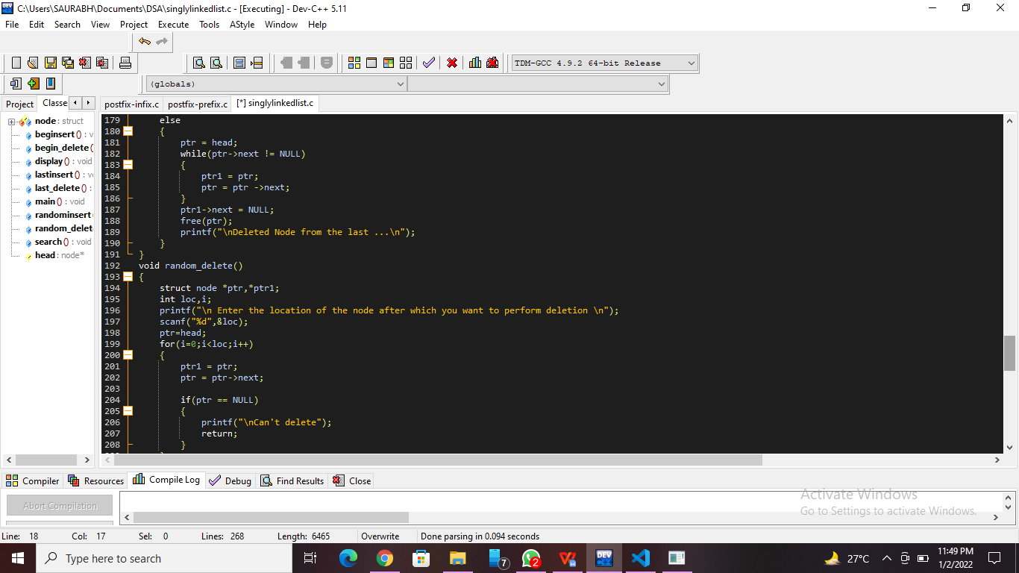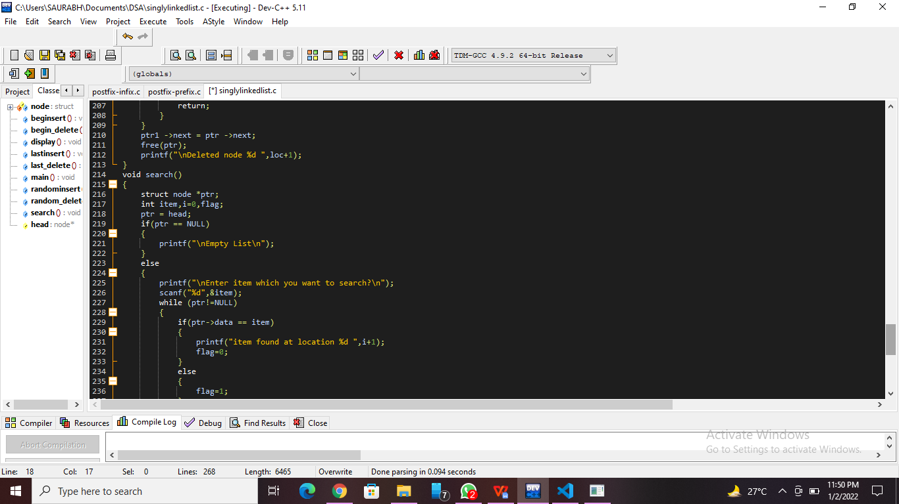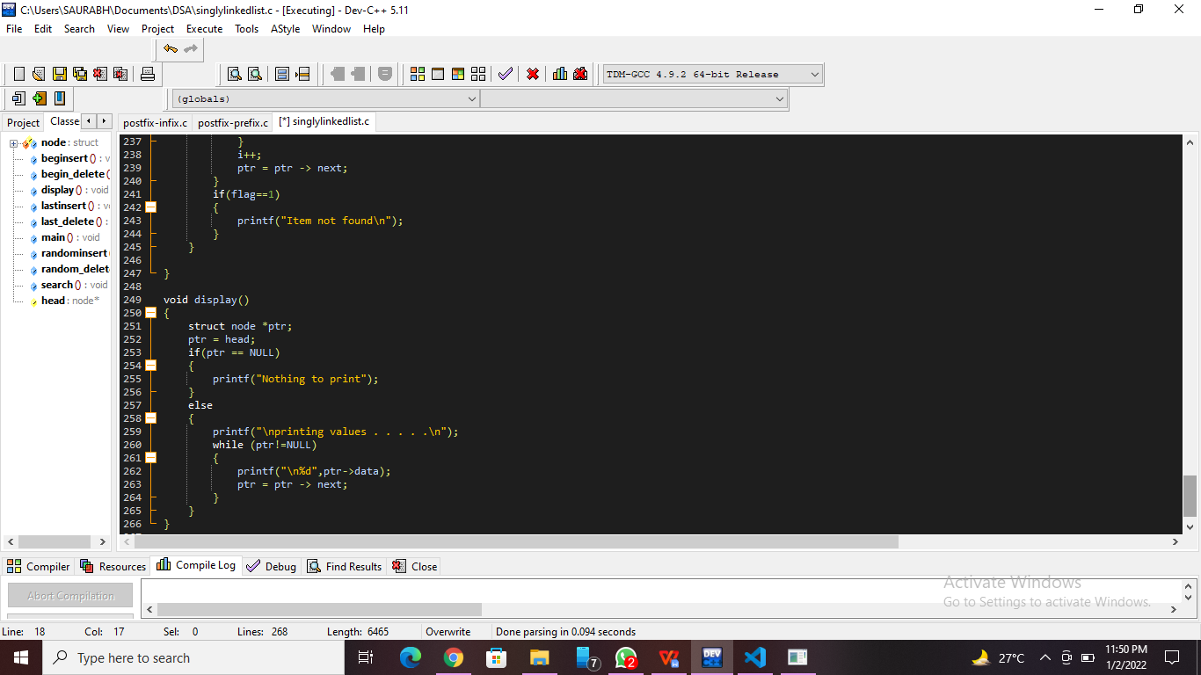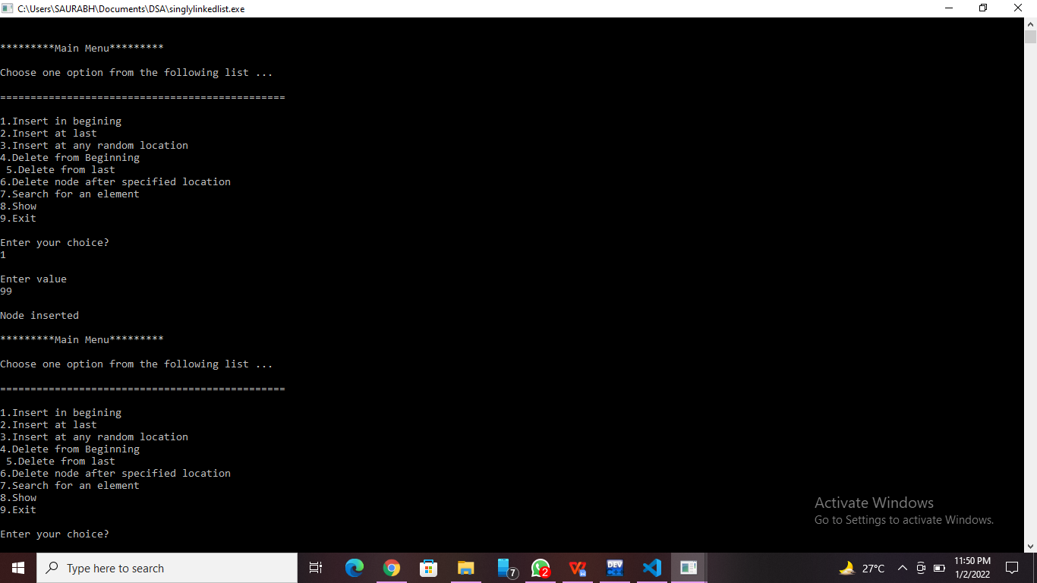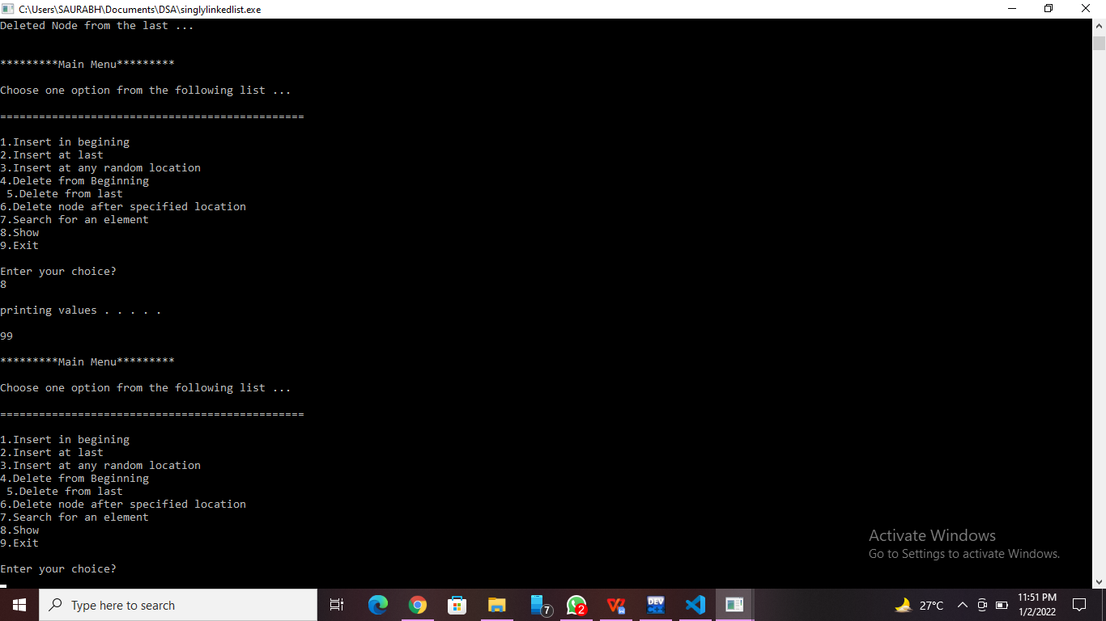

**Practice Program:**Write a C program to reverse items in the linked list.

//Nanekar Saurabh Rajesh_20141212_I1

#include <stdio.h>

#include <stdlib.h>

struct node

{

    int num;

    struct node *next;

};

void create(struct node **);

void reverse(struct node **);

void release(struct node **);

void display(struct node *);

int main()

{

    struct node *p = NULL;

    int n;

    printf("Enter data into the list\n");

    create(&p);

    printf("Displaying the nodes in the list:\n");

    display(p);

    printf("Reversing the list...\n");

    reverse(&p);

    printf("Displaying the reversed list:\n");

    display(p);

    release(&p);

    return 0;

}

void reverse(struct node **head)

{

    struct node *p, *q, *r;

    p = q = r = *head;

    p = p->next->next;

    q = q->next;

    r->next = NULL;

    q->next = r;

    while (p != NULL)

    {

        r = q;

        q = p;

        p = p->next;

        q->next = r;

    }

    *head = q;

}

void create(struct node **head)

{

    int c, ch;

    struct node *temp, *rear;

    do

    {

        printf("Enter number: ");

        scanf("%d", &c);

        temp = (struct node *)malloc(sizeof(struct node));

        temp->num = c;

        temp->next = NULL;

        if (*head == NULL)

        {

            *head = temp;

        }

        else

        {

            rear->next = temp;

        }

        rear = temp;

        printf("Do you wish to continue [1/0]: ");

        scanf("%d", &ch);

    } while (ch != 0);

    printf("\n");

}

void display(struct node *p)

{

    while (p != NULL)

    {

        printf("%d\t", p->num);

        p = p->next;

    }

    printf("\n");

}

void release(struct node **head)

{

    struct node *temp = *head;

    *head = (*head)->next;

    while ((*head) != NULL)

    {

        free(temp);

        temp = *head;

        (*head) = (*head)->next;

    }

}

**Screenshots of Practice Program:-**

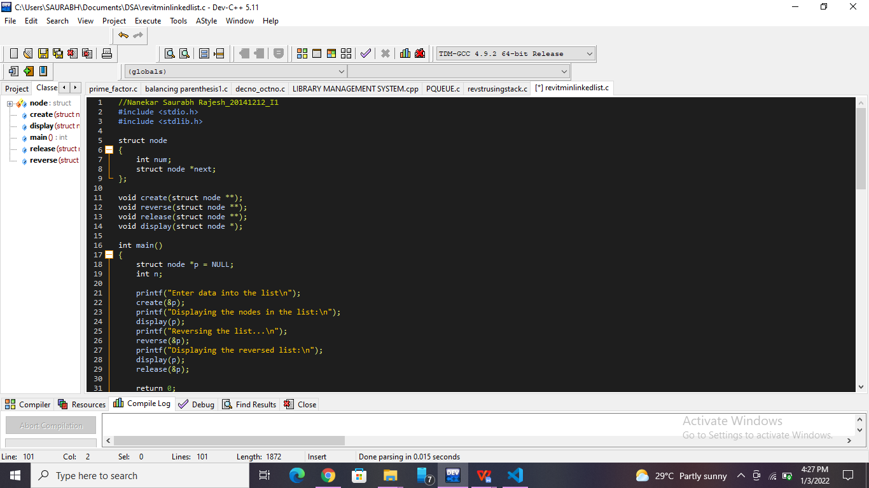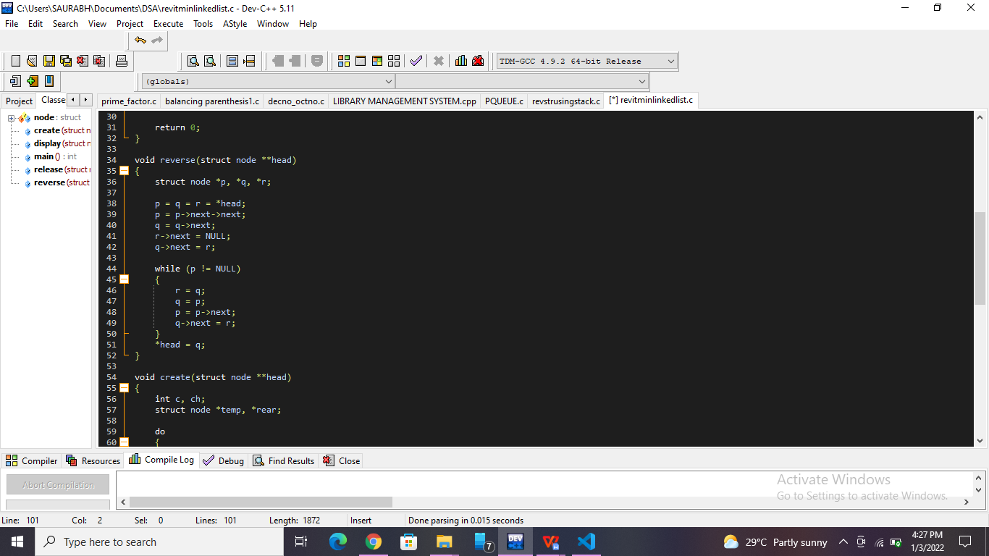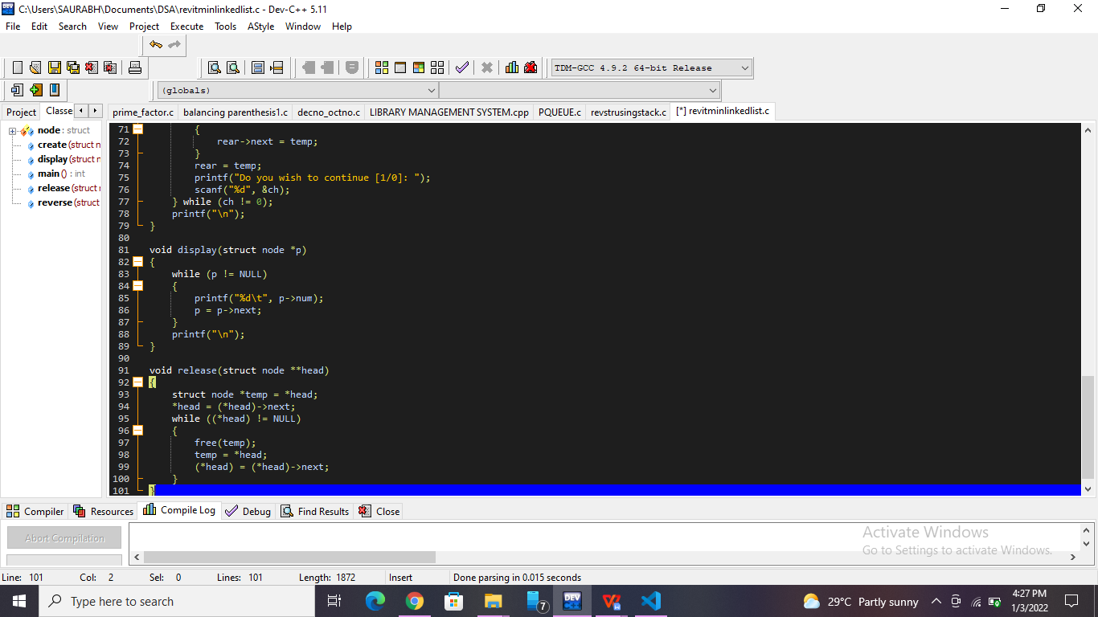

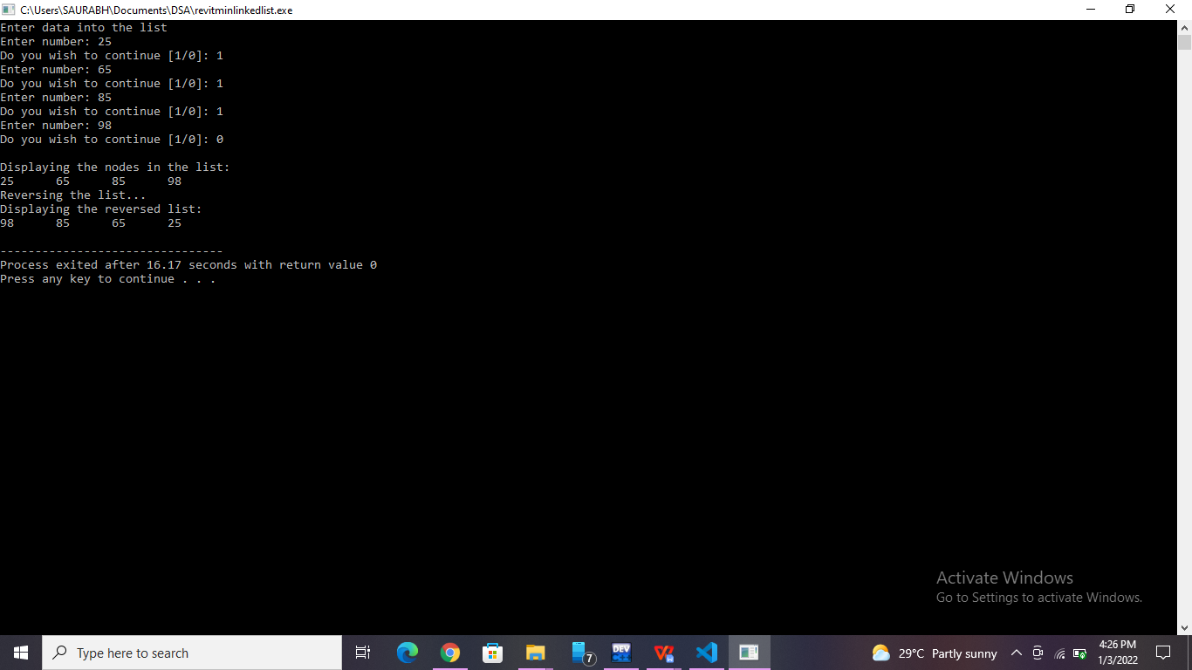

**List of sample questions for oral examination:**

1. What is singly linked list explain?
2. What is a singly linked list, doubly linked list and circularly linked list?
3. Compare arrays and linked list.
4. What are the advantages and disadvantages of linked list?
5. What type of memory allocation is referred for Linked lists?
6. Mention what are the applications of Linked Lists?

**Conclusion:**

Singly linked list is probably the most easiest data structure to implement. Insertion and deletion of element can be done easily. Insertion and deletion of elements doesn't requires movement of all elements when compared to an array.